November 2016
The Arizona Office of Tourism (AOT) is pleased to provide this monthly update of new and noteworthy items. AOT’s promotional focus centers on four primary areas: Culinary, Adventure, Culture & Heritage, and Wellness. This monthly update includes news within these areas and a section on hotel and resort news.

For more information, contact Tony Alba at talba@tourism.az.gov, Marjorie Magnusson at mmagnusson@tourism.az.gov, or Kim Todd at ktodd@tourism.az.gov.

Culinary

It’s no secret that the Wrigley Mansion has one of the world’s finest wine selections in its walls, with more than 96,000 bottles of wine poured a year, but the historic one-time home of one of gum’s biggest names has just upped its game with the launch of Jamie’s Wine Bar. The small, intimate addition to Wrigley’s sprawling grounds opened in November, granting Wrigley Mansion members and guests access to up to 25 premium by-the-glass wine offerings in addition to the 850 fine wines already available by the bottle at Geordie’s Steak. A tribute to Jamie Hormel, who purchased and preserved the mansion in 1992 alongside late husband, Geordie, Jamie’s Wine Bar came about when Jamie and her nephew, Michael, developed an interest in fine wine and wanted to create a special place for guests to enjoy rare and eclectic wine offerings not found anywhere else on property. The idea behind the name of the new bar concept came from the youngest Hormel daughter, Gillian, who wanted to create a space where Jamie and Geordie (the namesake of Geordie’s Steak) could live on indefinitely together under the same roof.

Kai restaurant at the Sheraton Grand at Wild Horse Pass was awarded AAA's highest rating and is the solitary Five-Diamond restaurant in the state of Arizona and one of the few in a small group of Five-Diamond restaurants in the nation. This marks Kai’s 11th Five-Diamond designation. The Sheraton Grand at Wild Horse Pass is a destination resort showcasing the heritage, culture, art and legends of the Pima and Maricopa Tribes.

In 2005, Flagstaff was home to the first legal distillery in Arizona and after many dormant years a new team is working the still. Production began at Canyon Diablo Spirits on varieties including: Sonoran Rose Prickly Pear flavored Vodka, Desert Rain American Dry Gin and Two Ghosts Chili Pepper flavored Vodka. The company was named for Canyon Diablo, a real, but little known, true Wild West town located east of Flagstaff. It was meaner than Dodge City and Tombstone combined, and called the toughest hellhole in the West. It is this legacy that inspires and influences the master distiller to create bold and memorable flavors.

Three Arizona locations made OpenTable's 100 Best Restaurants in America for 2016: Barrio Cafe Gran Reserva at 1301 Grand Ave, Phoenix, barriocafe.com; Kai: Sheraton Grand at Wild Horse Pass on the Gila River Indian Reservation, 5594 Wild Horse Pass Blvd., wildhorsepassresort.com/kai; and Monarch at 6934 E. First Ave. in Scottsdale, cafemonarch.com.

Adventure

What began in 2008 as an off road experience on the Fort McDowell Indian Reservation has evolved into "Arizona's Action Concierge." Green Zebra began booking services at the Hyatt Gainey Ranch Resort, and in November expanded its offerings and opened its first retail store in Old Town Scottsdale. Those anxious to learn about the dozens of bucket list worthy excursions available throughout the state can now belly up to the "Adventure Bar" and book anything from an adrenaline-fueled afternoon at the Bondurant race track to a helicopter tour of the Grand Canyon, while enjoying a sample of Arizona wine or craft beer.

The tree-top thrills at the Flagstaff Extreme Adventure Course are soaring to new heights with the addition of the Adventure Zip Lines Course, scheduled to be open by the end of 2016. Adrenaline seekers will find a network of 30 zip lines zig zagging through the Ponderosa pines of Fort Tuthill County Park sending participants deeper into the surrounding forest. While the majority of the experience will be cruising through the air high above the forest floor, riders will have to climb seven ladders and traverse eight bridges to get to some of the zip line take off platforms. The zip line course joins the highly popular adventure course which offers more than 70 aerial challenges divided into five difficulty levels. flagstaffextreme.com

In October, the City of Sierra Vista released its newest map, the Bicycle Mountain Trail Map. This pocket-sized piece features four popular trails in the adjacent Huachuca Mountains and includes elevation and trail descriptions. It can be downloaded here: http://www.sierravistaaz.gov/wp-content/uploads/2016/11/2016-Mountain-Bike-Map.pdf. It’s a great companion piece for the Bicycle & Multi-use Path Map for road riders. Sierra Vista also recently extended the Cochise Vista Trail (a marked multi-use path) to include low-traffic roadways, designating the Cochise Vista Trail Loop, a 20-mile paved route signed for bicyclists, and can be downloaded here:
http://www.sierravistaaz.gov/wp-content/uploads/2016/11/Cochise-Vista-Trail-Map.pdf

Culture/Heritage

Retired Scottsdale gallery owner and long-time Valley resident Abe Hays has donated “The A.P. Hays Spirit of the West Collection” of 1,400 authentic Old West objects to the Western Spirit: Scottsdale’s Museum of the West. This is a one-of-a-kind collection of the best items of their type, dating back to the 1800s. Much of the collection has been on exhibit since the opening of the museum in January 2015 (on loan). During 2016, the number of items included in the exhibition has steadily increased. As of November 2016 the exhibition now contains all of them. The model for the museum, which is very unusual, is that everything on exhibit is on loan. This makes the “A.P. Hays Spirit of the West Collection” the first permanent collection. The more than 1,400 authentic Western artifacts including exquisitely tooled leather saddles (some of which date back to the 1800s), rare badges, spurs worn by rodeo stars and working cowboys, firearms, Wild West Show objects, and a “wanted” poster for the arrest of legendary outlaws Clyde Barrow and Bonnie Parker. Scottsdale’s Museum of the West is located in downtown Scottsdale at 3830 N. Marshall Way, one block west of Scottsdale Road at 1st Street, near the Main Street galleries.

In 1885, a small White Lady Banksia rose tree was planted behind a Tombstone boarding house. In 1936, that same rose tree had grown so large that it was named the “World’s Largest Rose Tree” in Robert Ripley’s ‘Believe It or Not’ column. In 1964, the Rose Tree Museum was opened to the public, And now, Burt and Dorothy Devere, owners of the World’s Largest Rose Tree and proprietors of Tombstone’s Rose Tree Museum, have announced that Tombstone’s original Shady Lady has a new website – TombstoneRoseTree.com. The web site features stories and photos of the World’s Largest Rose Tree and one of Tombstone’s oldest original families, the Robertson-Macia family. TombstoneRoseTree.com also contains information about the Rose Tree Museum and Tombstone’s Annual Rose Festival along with video footage of the rose tree in bloom and a photo gallery. Email info@TombstoneRoseTree.com or call 520-457-3326.

Hotel Development
Flagstaff’s historic downtown core has not seen new hotel construction for more than 60 years, but the corner of Aspen Avenue and Humphreys Street is currently undergoing a transformation. A 110-room Marriott Residence Inn is under construction and is scheduled to open May 2017. The east edge of Flagstaff will also soon be home to new lodging options with a Fairfield Inn & Suites under construction just off Interstate 40 at the Country Club Drive exit. The property is scheduled for completion in spring 2017. http://www.flagstaffarizona.org/

General

The Desert Botanical Garden broke ground on a new, expanded butterfly exhibit in November, 2016. Opening in March 2017, the new Butterfly Pavilion will be located on the Harriet K. Maxwell Desert Wildflower Loop Trail and will feature hundreds of live butterflies, as well as a caterpillar nursery and emergence chamber. The exhibit will provide visitors an opportunity for up close interaction with butterflies while learning about their role as pollinators, characteristics of the butterfly in different lifecycles, and conservation efforts to protect them. The seasonal pavilion opens to all Garden visitors on Saturday, March 4, 2017. The Butterfly Pavilion will be open daily through May 14, 2017 from 10 a.m. to 5 p.m.

Arizona State Parks has added a new park. Granite Mountain Hotshots Memorial State Park opened November 30. The park is near the site where 19 Granite Mountain Hotshots sacrificed their lives while battling one of the most devastating fires in Arizona's history. From the trailhead, the Hotshots Trail is a 2.85 mile path up to the Observation Deck. Every 600 feet, 19 granite plaques set into rocks share a photo and a story of each fallen Hotshot. Additional interpretive signage provides information about wild land firefighting. An additional 3/4-mile Journey Trail allows visitors to follow the last steps where they made their last stand. The trail is seven miles round-trip. The trail is considered a difficult hike, climbing 1,200 feet on the Hotshots trail and another 400 feet out on the Journey Trail.
http://www.granitemountainhotshotsmemorial.org/news-and-events or http://azstateparks.com/

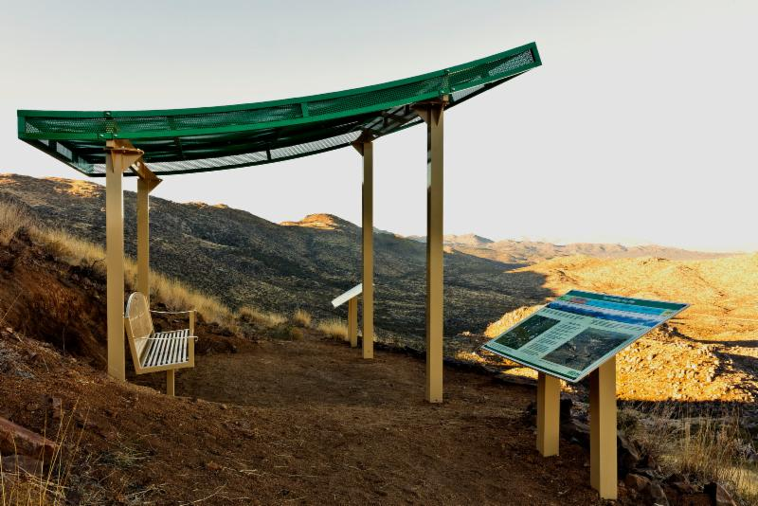
Granite Mountain Hotshots Memorial State Park

Picture a small village of tinkerers together in an old Quonset hut made of the steel from former WWII airplanes from the 1940s. But, it is more than a place for tinkerers. It’s an open workshop space where guests can establish a relationship with the maker. Barnone is a community in Mesa, next to Agritopia, where skilled craftsmen make and sell their handcrafted goods. Barnone goes beyond retail, it’s seeing and doing – visitors can see the creative process and interact with the artists. Under the Barnone roof are 12 of Arizona's best makers including a culinary machinist, modern day apothecary, experimental wine maker (Garage East), a nano-brewery (http://12westbrewing.com/), master woodmaker (Lettercraft), printing letterpress – (Prickly Pear Paper), hearth artisan baker, plant-based eatery (http://theuprootedkitchen.com/)and others. http://barnoneaz.com/

The Grand Canyon Caverns opened a new visitor center and gift shop on Route 66 in the historic Kozy Korner property at Antares Point (aka Gigaticus Headicus)between Kingman and the Hackberry General Store. The Route 66 Antares Road Visitor Center is currently open as an information center and additional amenities will be added this winter. By spring the center will include a convenience store, gift shop, art gallery, small restaurant, and picnic area, with beautiful views of the desert valley. Winter hours (November through March) are 9 a.m. - 4 p.m.

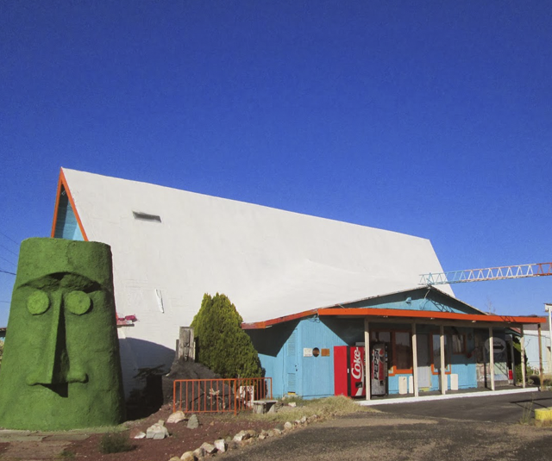
Route 66 Antares Road Visitor Center

There is a change in parking fees at the Airport Mesa Scenic Overlook in Sedona. Effective now, there is a $3 per vehicle charge to park at the Airport Mesa Scenic Overlook parking lot. There is a kiosk inside the lot near the Airport Road. You may pay by cash or credit card and the receipt is good for the day so you can visit in the morning and go back in the afternoon for sunset using the same parking receipt. This charge is being implemented to help fund a beautification project at the overlook including upgrading the overlook itself and relocating the pedestrian crosswalk to a safer location by next summer. Additional projects including paving the parking lot, improving bus parking and bus loading/unloading zones, installing solar toilets and recycling receptacles is scheduled to be completed in approximately 18 months.

Phoenix-Mesa Gateway Airport and NewLeaf Travel Company have announced new charter service from Canada to the Phoenix East Valley. The service, beginning in January 2017, will offer Canadian visitors convenient access to all the amenities the greater Phoenix region has to offer. NewLeaf will operate three nonstop flights each week from Calgary starting on January 19, and once weekly nonstop service from Edmonton starting on January 21. Flights can be booked at http://gonewleaf.ca/.

Accolades
Paradise Valley was rated the #2 most comfortable city in America by travelers in a recent article by Expedia. Guest reviews were analyzed to determine the cities across the United States with the highest ratings in hotel comfort. Tourists often consider recommendations from other travelers and the conditions of accommodations when determining new places to visit and this feature signals that they will be comfortable and welcomed when staying in your city.
Read the article: 101 Most Comfortable Cities

ThePointsGuy.com named Phoenix Sky Harbor Airport as the number one of the ten best airports in the U.S. https://thepointsguy.com/2016/11/best-and-worst-airports-usa-2016/

The McDowell Sonoran Conservancy is celebrating 25 years of desert preservation. The nonprofit organization, which was founded in 1991, champions for the sustainability of the McDowell Sonoran Preserve for the benefit of current and future generations.

Connect:
Facebook: @arizonatravel
Twitter: @AZTourismPR
Instagram: @visit_arizona/
YouTube: www.youtube.com/user/ArizonaTourism

