August 2016
The Arizona Office of Tourism is pleased to provide this monthly update of new and noteworthy items within the state’s tourism industry. AOT’s promotional focus centers on four primary areas: Culinary, Adventure, Culture & Heritage and Wellness. This monthly update includes news within those four pillars and also includes a general section, a section on hotel and resort news and accolades.

For more information, contact Tony Alba at talba@tourism.az.gov or 602-364-3715 or Marjorie Magnusson at mmagnusson@tourism.az.gov or 602-364-3695.

Culinary

Historic D.A. Ranch Lodge & Estate Vineyards is now offering wine tastings in the Verde Valley. The historic D.A. Ranch is open for tastings of their 100% estate-grown wines, with weekly tasting hours every Wednesday from 11 am - 5 pm by appointment only. Call or text (928) 301-0791 or email info@daranch.com to schedule an appointment. The D.A. Ranch is a small, family-owned vineyard, working ranch and special-event destination located in the heart of the Verde Valley. The D.A. Ranch and its 100-year-old red barn mix old and new family traditions and is representative of a new contemporary sensibility towards the land and its use. http://daranch.com/

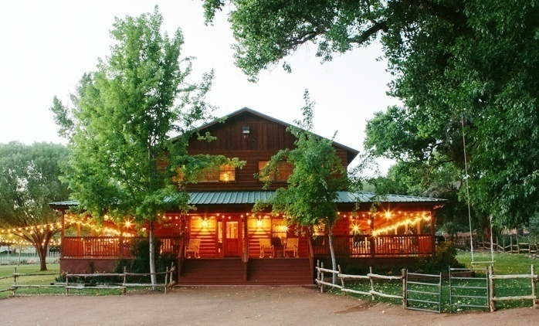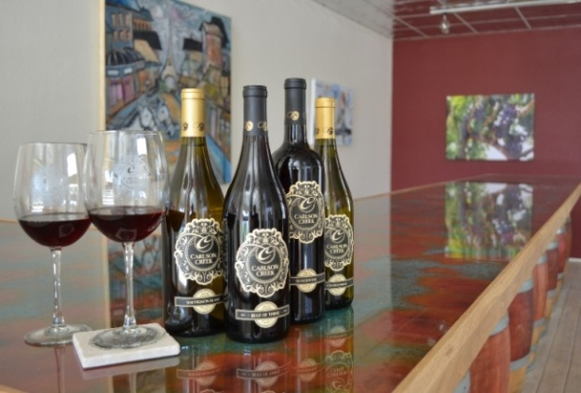
D.A. Ranch Carlson Creek Tasting Room

Carlson Creek is in the midst of its biggest expansion in the company’s seven-year history. It recently purchased new space in Willcox and is opening a tasting room in Scottsdale this summer.
The new Willcox space, located at 469 S. Haskell Ave., is a 14,000-sq. ft. building that originally housed a Chevrolet dealership built in the 1940s. Carlson Creek also is leasing space in the Scottsdale arts and entertainment district at 4142 N. Marshall Way. The 2,300-sq. ft. space will house a new tasting room with a 20-foot distressed copper bar built by Bootleg Barrel Company. It will include an education room for private wine tastings and events. https://carlsoncreek.com/

Downtown Tempe’s Pedal Haus Brewery is expanding its brewing capacity and will re-launch in early October 2016. The expanded restaurant will include an increased brewing capacity, private dining room, enhanced patio area and beer garden and an expanded beer selection. Pedal Haus Brewery will

resemble a contemporary German beer garden with a rustic twist. The brewery will re-locate large fermentation tanks to a centralized area in the dining room for guests to have a window into the brewing process along with accessibility of newly offered brewery tours. Retractable large metal garage doors will open up to the outdoor seating area, offering an open-air feel, full-functioning bar, yard games such as ping pong, cornhole, ladderball and communal bungalows with fire pits available to rent for parties of 10 to 20 people. The restaurant will include 38 televisions ideal for sports viewing and happy hours. www.pedalhausbrewery.com

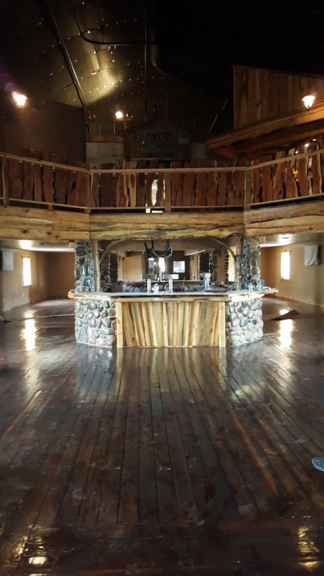
Grand Canyon Brewing Brewhouse

The Grand Canyon Brewing Company is expanding with the addition of a brand new brewhouse and tap room located just two miles down Route 66 from their current location in Williams, AZ. The tap room grand opening is scheduled for Thursday, July 28, 2016. The brewhouse will begin production in January 2017 and the 20,000 square foot facility will be fully functional by November doubling the brewing capacity over the next two years to 40,000 barrels by 2020. Currently distributing in Arizona, Nevada and South Korea, the expansion has its sights set on distribution into China, Canada, Mexico, Japan and Australia. In addition to increased production of its core beers, the Grand Canyon Brewing Company plans to increase small batch and specialty beers including their "Shotgun Series", a set of four different seasonal double IPAs, a cask program, and other unique collaborations. www.grandcanyonbrewery.com

Adventure

Tempe is working to bring the regional bicycle sharing program GR:D to the community in February 2017. GR:D bikes are currently available in Phoenix and Mesa. Tempe plans to launch the for-rent public bike program in late fall/early winter with 300 bikes and 31 stations. Station locations are targeted to

reach the highest bike ridership parts of the community, major destinations, bikeways as well as link to the regional light rail system and the streetcar route. Rental use is by the hour, month or year. www.tempe.gov/bikeshare

In November 2015, the League of American Bicyclists (LAB) designated Tempe as a Gold Level Bicycle Friendly Community through 2019, upping the city’s previous designation from Silver. Tempe has been designated a Bicycle Friendly Community since 1997, with LAB adding the Silver level designation in 2002. Tempe is one of 25 cities in the country that have Gold status and the city boasts 175 miles of bikeways. Tempe uses the best methods for integrating bicycling and bicycle infrastructure into all levels of city planning. www.tempe.gov/bike

Culture/Heritage

White Stallion Ranch was selected for membership by Historic Hotels of America. To be nominated, a hotel must be at least 50 years old; been designated by the U.S. Secretary of the Interior as a National Historic Landmark or listed in or eligible for listing in the National Register of Historic Places; and recognized as having historic significance. White Stallion Ranch was established as a cattle ranch in 1939. It has been owned and operated by the True family for 50 years as a guest ranch, and has been ranked the #1 hotel in Tucson on TripAdvisor for 5 consecutive years. http://www.whitestallion.com/
Video - https://youtu.be/OlJHqXIZ1TA

The Winslow Arts Trust has purchased an original Turquoise Room train car, and will soon be moving it to Winslow for the Route 66 Art Museum. The project will go to bid for construction this summer of 2016 and should open to the public next spring. The $1 million first phase of the museum is being funded by the Winslow Arts Trust and the National Transportation Enhancement program in cooperation with the City of Winslow. The #502 train car will be open to the public as part of the museum and will be located immediately east of the Winslow Depot on the private train track owned by La Posada. The 7,000-square-foot museum will feature both historic spaces and contemporary art galleries. The central passenger waiting room will be restored to its original grandeur and will act as a visitors center for artist James Turrell’s Roden Crater.

The Winslow Arts Trust must raise $50,000 - $100,000 to complete the restoration project. Call Allan Affeldt at 928-587-3268 for more information. http://winslowartstrust.org/about/

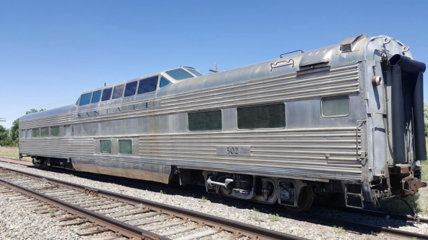
#502 Turquoise Room train car

Visitors to the Hopi reservation can now enjoy tours leaving daily from the lobby of the Moenkopi Legacy Inn & Suites near Tuba City. Tours connect visitors with unique landscapes, Hopi culture, art, and artists. Tour stops include one of the largest concentrations of petroglyphs in America on the walls of a unique box canyon that was the hub of early communities; Coal Mine Canyon a panorama of delicately coloured stone spires and canyon walls carved by wind and water over the millennia; and Prophecy Rock a Petroglyph that stands alone and connects visitors with the one of the core principles of Hopi life. Meet Hopi artists including visits to home workshops. Experience Hopi Tours was created for the benefit of the Hopi people by the Moenkopi Developers Corporation, a non-profit entity dedicated to job creation and preservation of Hopi culture and language. Tour descriptions and information for reservations at www.ExperienceHopi.com. All Experience Hopi Tour guides are authorized by the Hopi Tribe.
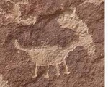

Experience Hopi Tours

Wellness

Miraval Resort & Spa in Tucson is offering a new bee curriculum led by resident beekeeper and local Tucson resident, Noel Patterson. In addition to building new hives at Miraval, Noel has developed a
series of new bee programming, including an immersive beekeeping experience that involves donning beekeeping suits for an up-close and personal look at the hives, a honey tasting experience designed to introduce guests to the unique terroirs of Tucson and an informational lecture on bees’ role in our ecosystem.

Miraval Resort & Spa also has added six new signature spa experiences to its menu of more than 100 state-of-the-art treatments. New bodywork treatments include a Crystal Salt Serenity with a deeply refining salt and oil scrub, followed by an advanced massage using warm Crystal Salt Stones; and 3-in-1 Detox and Firm Treatment where skin is smoothed with a salt and oil scrub and then cocooned in a detoxifying algae wrap. A contouring massage that uses colonic stomach movements and lymphatic drainage completes the treatment. Energy treatments include an Intuitive Massage influenced by Native American spirituality and Peruvian Shamanic studies, incorporating spiritual wisdom, sacred plants, artifacts and natural objects; and Pachamama Medicine, inspired by Incan Shamanic traditions to strengthen the mind-heart-body. The treatment combines chumpi stones to balance energy with healing techniques. Beauty treatments include a Desert Rose Radiance Facial featuring a massage with cool Rose

Quartz Crystals; and Become a Maharani (Hindu Queen) for a Day which includes applying henna on hands and feet. http://www.miravalresorts.com/

The Petrified Forest Museum Association (PFMA) has launched its inaugural season of the Petrified Forest Field Institute (PFFI). PFFI offers outdoor learning opportunities – the park is the classroom. Classes will cover geology and paleontology, archaeology, human history and photography in this first season. Petrified Forest National Park in northeast Arizona preserves some of the most pristine and
colorful deposits of petrified wood from the Late Triassic Era (200 – 225 million years ago). www.petrifiedforestfieldinstitute.org.

General

The National Park Service (NPS) and the International Dark-Sky Association (IDA) announced Grand Canyon National Park is now a Provisional IDA International Dark Sky Park, an important step in ensuring the Colorado Plateau remains a protective harbor for some of the best night skies in the country. Grand Canyon joins 11 other national park sites certified by IDA. Including Grand Canyon, eight of the national park sites with IDA Dark Sky Park status are located on the Colorado Plateau.
Grand Canyon plans to complete the necessary lighting improvements to receive full IDA Dark Sky Park certification in 2019 - the 100th anniversary of the national park. Grand Canyon’s night sky walks and talks – an important part of the application process and integral to receiving Dark Sky Park Status –provide visitors an opportunity to learn about this nationally significant resource and the continued efforts of the NPS, IDA, and GCA. For more information about IDA, visit www.darksky.org. For more
information about night skies in national parks, visit https://nps.gov/nsnsd. To learn how you can help protect Grand Canyon’s night skies, visit www.grandcanyon.org.

LEGOLAND® Discovery Center Arizona, the first attraction of its kind to open in the state, boasts two LEGO® rides, a 4D Cinema and endless opportunities for creative play. It is located at Arizona Mills in Tempe and opened in April 2016. In addition to massive, large-scale models, LEGO® building areas and festive party rooms for birthday celebrations, the 40,000 square-foot facility features a Master Model
Builder responsible for maintaining and updating LEGO® MINILAND models. www.legolanddiscoverycenter.com/arizona

Tilt Studio Opening in August
Tilt Studio is slated to open August 2016 in Tempe's Arizona Mills. The two-story 40,000 square-foot family entertainment center will feature a unique combination of “food, fun and 'freshments” (alcoholic and non-alcoholic), in a safe, clean and welcoming environment. Guests will enjoy more than 150 classic and modern interactive video and redemption prize games for all skill levels. An entire retro gaming area on the second level will be home to favorite pinball and arcade games such as Space Invaders, Pac Man and Asteroids as well as interactive games such as Monster Drop Extreme, Sponge Bob and Ghost Busters. www.tiltstudio.com/tilt-studio-arizona-mills

Hotel News
Marriott International opened first U.S. Moxy Hotel in Tempe in spring 2016. This provocative new lifestyle brand, the chic and modern Moxy Tempe offers the style and spirit of a boutique hotel. It welcomes guests with its locally inspired contemporary design, affordable style and buzzing social scene. The 186 bedrooms are comfortable, industrial-chic and tech savvy. www.moxy.com/phxox

AC Hotel Phoenix Tempe/Downtown opened in June 2016, becoming the first hotel to be located on iconic Tempe Town Lake. This new property features muted colors and a sleek, timeless design. The 159 guest rooms have hardwood floors, modern furnishings and crisp white linens. Guests can enjoy local craft beers, specialty wines on tap, signature cocktails and tapas-style small bites in the AC Lounge. The AC Kitchen offers a European-inspired continental breakfast. The six-story hotel features a rooftop pool with views of Tempe and Arizona State University’s Sun Devil Stadium, along with a fitness center with floor-to-ceiling windows overlooking the iconic “A” Mountain. The AC Library, which serves as a central work area for guests to be both connected and inspired, offers complimentary computers, wireless printing and two private media salons. www.marriott.com/phxac

The Historic Hat Ranch, established in the 1800's offers beauty, seclusion, horseback riding, hiking, bird watching, star gazing, and rest and relaxation. Bring your own horse (boarding is available) or take a ranch horse on the 2,800 acres of private ranch land at 6,700 feet in elevation next to the Kaibab National Forest. The entire ranch runs on solar power and they have reliable cell service. Internet connection is available in the Main House and the road to the ranch is open year-round. It is located six miles west of Williams. http://historichatranch.com/

The Saguaro Scottsdale Hotel in Old Town Scottsdale is undergoing renovations set to be finished in October. The event and meeting space will add more than 12,000 square feet of indoor and outdoor space with the addition of the Agave Ballroom and Patio, a 5,285-square-foot event complex with a
wraparound patio with fireplaces, fire pits and multiple outdoor dining and entertaining spaces. 194 guest rooms will be renovated to include sound-proof wood doors; guests check-in and access their rooms via smartphone; pillow-top mattresses and ergonomic desks; 42-inch flat screen cable TVs, Keurig coffee makers, mini-refrigerators, natural wood vanities and Lather bath products; and new art including
pieces from photographer Colleen Durkin. New York-based Sydell Group, owner of Saguaro Scottsdale, will be taking over management of the hotel. http://thesaguaro.com/scottsdale/new-rooms/

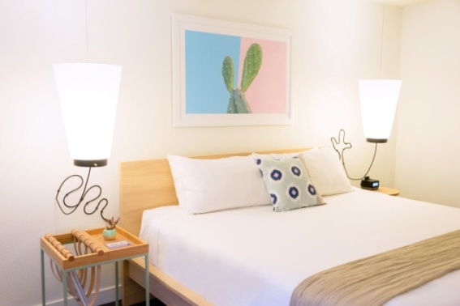
The Saguaro Scottsdale Hotel
Accolades

The town of Gilbert has been recognized nationally this month for several accomplishments.

2nd Safest City - http://lawstreetmedia.com/blogs/crime/crime-america-2016-top-10-safest-cities-200000/2/

Best Phoenix Suburb – https://www.thrillist.com/travel/nation/best-suburbs-in-america-the-best-suburb-in-35-american-cities

Top 10 Cleanest City in the US - https://viewfinder.expedia.com/features/ranking-the-cleanest-cities-in-the-u-s/

U.S. News & World Report, a nationally recognized publisher of consumer advice and information, released its annual rankings of the Best Vacation Destinations in June 2016. The new rankings highlight the World’s Best Places to Visit as well as region-specific lists, including the Best Places to Visit in the USA and the Best Places to Visit in the Caribbean. The Grand Canyon tops the list of the Best Places to Visit in the USA. Two other national parks – Yellowstone and Yosemite – make the top five due to their affordability and family-friendly activities. http://travel.usnews.com/Rankings/best_usa_vacations/

Connect with us:

- Facebook: @arizonatravel

- Twitter: @AZTourismPR

- Instagram: @visit_arizona/

YouTube: www.youtube.com/user/ArizonaTourism

