September 2016
The Arizona Office of Tourism is pleased to provide this monthly update of new and noteworthy items. AOT’s promotional focus centers on four primary areas: Culinary, Adventure, Culture & Heritage and Wellness. This monthly update includes news within those areas and also includes a general section as well as a section on hotel and resort news.

For more information, please contact Tony Alba at talba@tourism.az.gov , Marjorie Magnusson at mmagnusson@tourism.az.gov or Kim Todd at ktodd@tourism.az.gov.

Culinary

Willcox has been recognized as an American Viticulture Area (AVA), a designated wine grape-growing area with geographic features and boundaries defined by the Alcohol and Tobacco Tax and Trade Bureau (TTB) of the United States Department of the Treasury. Willcox is the second wine region in Arizona to be designated as an AVA. Read more here.

After 70+ years of ownership by the Wong family, the operation of Grand Canyon Cafe in Flagstaff is passing to new owners who will carry on Wong family legacy of the historic diner on Route 66. The cafe is being purchased by local brewers Michael and Alissa Marquess and local restaurateurs Laura and Paul Moir. Grand Canyon Cafe on historic Route 66 has been operated by the Wong family since 1943. The new owners intend to honor the history by preserving a selection of menu favorites and maintaining the integrity of the dining room with many of the 1940's booths, counter and neon intact. They will bring the Marquesses’ craft beer influence and the Moires’ wine and food knowledge to the menu and also plan to bring back the ice cream counter and compounded sodas that were part of the original cafe. It will re-open in December 2016 and is located at 110 Historic Rte 66, Flagstaff, AZ 86001.

Five downtown Scottsdale wine tasting rooms have joined forces to launch the “Scottsdale Wine Trail.” This cooperative of wineries and their united efforts will continue to advance education and exposure for Arizona produced wines and wineries. All of the wineries have tasting rooms and retail shops that are within walking distance. The Scottsdale Wine Trail features an official SWT Passport to oenophiles or just everyday wine lovers offering SWT swag, and special discounts for completing the Wine Trail tasting program. Details and signup for the SWT Passport are online at www.scottsdalewinetrail.com.

Adventure
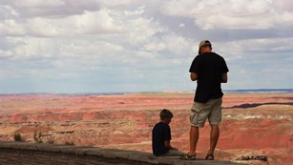
Petrified Forest National Park

Petrified Forest National Park has launched a second year of Every Kid in a Park Pass. The Park was selected by the National Park Foundation to receive a 2016 field trip grant as part of the Open Out Doors for Kids program. The Petrified Forest National Park encourages all fourth graders to visit the park for free this year and offers grand vistas of the Painted Desert and one of the largest deposits of petrified wood in the world. Fossils of Late Triassic plants and animals as well as 13,000 years of human history can also be experienced. A 28-mile long road winds through the park and offers plenty of kid-friendly stops and walks. Visit www.EveryKidinaPark.gov to download the pass and obtain more information. For park hours of operation, visit www.nps.gov/pefo.

Arizona State Parks opened a newly constructed boat ramp at Lake Havasu State Park on September 2. The boat ramp takes pressure off the main launch site and allows for less congestion when launching and loading boats. A new exit and more parking has also been added to alleviate traffic at the park.

Arizona Snowbowl in Flagstaff will open its 2016-17 winter ski season on Friday, November 11, with a new feature, the new Grand Canyon Express. The Grand Canyon Express is Arizona’s only high-speed six-person lift and is aptly named because riders can see Grand Canyon from the lift. It will transport skiers up the mountain in six minutes. The new lift is just over a mile in length (5,801 feet) with a vertical rise of 1,546 feet and will provide access to more than 80 percent of the ski area. The top terminal is located on Ridge Trail at 10,900 feet in elevation. Lift capacity is 1,800 persons per hour. This year’s opening day is the earliest opening in the resort’s history.
The Four Seasons Resort in Scottsdale and Arizona Outback Adventures have created an exclusive guided experience offered only to Four Seasons guests - Sip, Cycle and Soar. The tour showcases the Verde Valley's beauty, from red rock formations to vineyards. It begins with an aerial tour of Sedona and Oak Creek Canyon, above stunning sandstone buttes, impressive monuments and the dramatic landscape of the canyon. Afterwards, guests ride amidst the lush flora on a guided bike tour to Page Springs Cellars vineyards and winery, where they will cool down with a wine tasting and a bucolic outdoor lunch. After recharging by the calming waters of Oak Creek, guests continue with a nature walk in Red Rock State Park. Guides will offer an insight into the history, geology and diverse vegetation of the mesmerizing Southwest.
Culture/Heritage

The OdySea Aquarium opened in Scottsdale on Saturday, September 3. Located at the Salt River Pima-Maricopa Indian Community, it is the largest aquarium in the Southwest, spanning 200,000 square feet. The two-level, state-of-the-art facility holds more than 2 million gallons of water and can accommodate more than 10,000 visitors daily. The OdySea Aquarium offers an educational, interactive and entertaining experience for guests by combining theme-park-style amusement with engaging presentations of aquatic life. The facility includes a 3D theater, SeaTREK™ underwater ocean walking and a one-of-a-kind voyage through the “Living Sea.” Visitors may also participate in scheduled daily events throughout the day such as feedings, enrichment sessions for the animals, and question and answer sessions with aquarists.
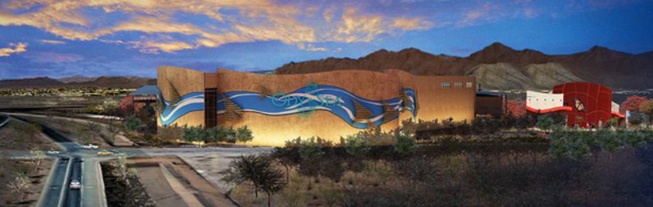
The OdySea Aquarium in Scottsdale

The old brick and adobe buildings lining Tempe’s Mill Avenue have stories going back to the 1800s. Now, as you walk through downtown Tempe, you can learn the secrets of the buildings, see what they looked like when they were new and hear about their original owners and uses. The City of Tempe has launched the Downtown Tempe – Walk Through History interactive StoryMap. The map includes an interactive self-guided walking tour of downtown Tempe, viewable on smart phones and devices, side-by-side historic and modern photos of historic buildings and Tempe points of pride, and access to additional resources and site data for each individual property through links to the Tempe Historic Property Register. Future phases of StoryMap will include video stories. Additional traditional maps are available at www.tempe.gov/historicpres under Maps and Tours.

A new model train has been installed in the Flagstaff Visitor Center, located at 1 East Route 66. The train engine is a scaled-down replica of an historic logging train called “Two Spot” that worked in Flagstaff from 1911-1949, also known as Baldwin Locomotive #35938. The actual locomotive is on display in downtown Flagstaff just a block east of the Flagstaff Visitor Center and is on the National Register of Historic places. People will be able to visit and see both the original and the model while visiting downtown Flagstaff. The model train track circles the perimeter of the Visitor Center interior. Visitors can pay a small fee and have the opportunity to push a button to make it chug to life followed

by several minutes of watching it go around the room. In mid-October a model of downtown Flagstaff and a mural in the northwest corner of the building that will show more Flagstaff history will be added.

Wellness

The age-old tradition of infusing water with gems dates back thousands of years, and now Amara Resort and Spa in Sedona is the first in the state to use VitaJuwel gem water in their spa treatments with a variety of gemstone blends available. Each mixture of crystals focuses on a different element to harness the mind, body and spirit. From fostering tranquility to regulating the metabolic energies of the body and achieving the perfect balance before meditation, there is a gemstone blend for every need. For more information visit www.amararesort.com.

Sedona's Amara Resort VitaJuwel gem water

At the Fairmont Scottsdale Princess' Well & Being Spa in Scottsdale, guests can "Sleep Well" with new innovative sleep-focused services using the A.R.T. of napping: the Acoustic Resonance Therapy in the So Sound Sleep Lounge, a zero gravity chair that induces total relaxation. Wearing headphones combined with vibration of the chair, guests can feel the music resonate through their body, creating a deep state of relaxation. Services start with a 30-minute Therapeutic Nap or the experience can be extended to one hour with the addition of Harmonized Acupuncture or Melodic Reflexolgy.

General

American Airlines launches nonstop service between New York (JFK) and Tucson. Service is set to begin October 7, 2016. This service not only opens up nonstop service to Tucson's largest feeder market for leisure travel, but also creates one-stop travel to and from numerous international destinations, as well as for cities across the northeast United States. The daily flights between Tucson and New York will be aboard a 160-passenger Boeing 737-800 aircraft featuring 16 recliner seats in first class, 30 main cabin extra seats with more legroom and 114 coach seats. Visit Tucson

Sedona offers visitors a holiday experience each year, with its Holiday Central Sedona, the annual series of events that includes glowing holiday trees, decorated storefronts and a plethora of shopping

options. This winter wonderland experience will be November 24, 2016, through January 9, 2017, with more than 30 events and festivals to be enjoyed throughout the

season. This year's Holiday Central Sedona affair welcomes the return of the historic Red Rock Fantasy. Red Rock Fantasy is a festival of nearly one million lights, providing a man-made marvel returning to the city December 1 through January 1 after a four-year hiatus. It includes two dozen displays created by community organizations and businesses from the Southwest.
The Tucson Botanical Gardens will host the New York Botanical Garden's blockbuster exhibit: Frida Kahlo: Art, Garden, Life from October 10, 2016 through May 31, 2017. This exhibit examines Kahlo's work through the lens of the plants and nature in her paintings and her personal gardens and will be accompanied by cultural celebrations and educational programming. Tucson Botanical Gardens was selected as the only institution to receive this extraordinary exhibition designed by one of the world's premier botanical gardens, the New York Botanical Garden. Tucson's exhibit will be more of a homecoming to familiar landscapes, celebrating Frida and her gardens against the vivid backdrop of the multicultural heritage of Tucson and the state of Arizona. Tucson Botanical Gardens is also working with Etherton Gallery of Tucson to curate a show of photos of Frida Kahlo by Nickolas Muray.

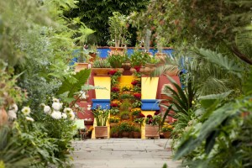

Tucson Botanical Gardens hosts the New York Botanical Garden’s exhibit:
Frida Kahlo: Art, Garden, Life.

Hotel Development
Mountain Shadows, the $100 million new boutique resort coming to Paradise Valley, is scheduled to debut in early 2017. Set in the shadow of Camelback Mountain, the property will feature a modern take on its iconic 1950s namesake. Rebuilt from the ground up, the new resort will feature 183 guest rooms, a presidential suite facing Camelback Mountain, a full-service restaurant - Hearth '61, two pools, a high tech fitness facility, an 18-hole golf and lounge experience, 37,500 square feet of indoor and outdoor event space, as well as on-site luxury resort condominiums and lofts available for purchase. The boutique shop, PV Mercantile, will offer high-end fashions, local products and artisanal food and wines curated to embody the Paradise Valley lifestyle. Design elements will include floor-to-ceiling glass windows and an abundance of outdoor patios and terraces, showcasing the property’s stunning views and serene spaces.
Marriott Courtyard Sedona is set to open its first Sedona location this fall. It will be the first new build for a hotel in Sedona in 10 years. The property will offer more than 120 rooms, a large outdoor area housing a pool, hot tub and fire pits backing up to the scenery of the red rocks. The hotel will also have an on-site café called The Bistro and offer nearly 1,480 square feet of meeting space and 1,500 square feet of event space on the rooftop.

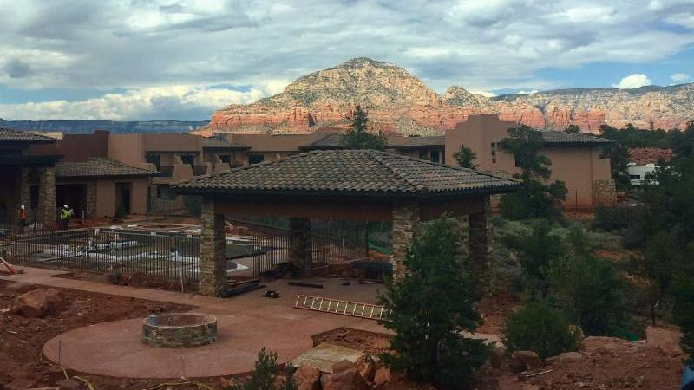
Marriott Courtyard - Sedona

Accolades
Gray Line Tours of Tucson celebrates 100 years. In 1916, Tom Morgan started a transportation company that linked the populations of Tucson and Nogales, Arizona. One hundred years later, the company has evolved into a full-scale transportation company that includes school transportation, cross-border and domestic freight, luxury motor coaches and an experiential tour and sightseeing division. Gray Line Tours of Tucson is celebrating its centennial in October.

Kai Restaurant, the five-star restaurant of the Sheraton Grand at Wild Horse Pass in Chandler, has been named one of the 100 Best Restaurants for Foodies in America by OpenTable. The list of winners is derived from more than 5 million reviews submitted by OpenTable diners for approximately 20,000 restaurants across the nation. For more information about all of the restaurants on this list or the selection process, visit http://www.opentable.com/m/best-foodie-restaurants-in-america-2016.

The Nash makes Phoenix one of 4 jazz "hubs" in America. The Jazz Forward Coalition has named The Nash, the popular jazz venue in downtown Phoenix as one of four partners in its national "jazz hubs" initiative. The Nash, along with major jazz venues in Pittsburgh (MCG Jazz), Washington D.C. (Smithsonian Jazz) and Portland (PDX Jazz) will lead the Jazz Forward Coalition, funded by the Doris Duke Foundation, to pilot a "jazz network" to strengthen jazz's cultural presence in the United States. In this

leadership capacity, The Nash will share and help create "best practices" for audience development, community engagement and programming for jazz venues across the nation.

A WalletHub report recently listed the Most Fun Cities in America, and the 2016 edition of the report included two of Arizona’s cities in the top 20. The 2016 list ranked Scottsdale number 10 and Tempe number 13 in the top 20 ranking.

Connect:
Facebook: @arizonatravel
Twitter: @AZTourismPR
Instagram: @visit_arizona/
YouTube: www.youtube.com/user/ArizonaTourism

