A Brief Update of News Around Arizona
May 2018
The Arizona Office of Tourism is pleased to provide this monthly update of new and noteworthy items regarding Arizona’s tourism industry. For more information, contact Becky Blaine at bblaine@tourism.az.gov, Kim Todd at ktodd@tourism.az.gov or Marjorie Magnusson at mmagnusson@tourism.az.gov.

Hotel News

CIVANA Carefree Now Open
CIVANA Carefree made its debut as the first sustainable wellness resort to open in Greater Phoenix. Grounded in its principles of sustainability, attainability and possibility, the forty million-dollar acquisition incorporates a natural design palette and materials, while improving energy efficiency and the introduction of solar energy in its new spa building. CIVANA focuses on four pillars – Healthy Cuisine, Movement, Healing Arts/Spa and Discovery & Enrichment. Only months after its acquisition, CIVANA Carefree has undergone a multi-million dollar renovation of its public spaces, 184 rooms, dining outlets, and the conversion of meeting spaces into state of the art fitness, yoga and enrichment studios. In addition to the world class programming CIVANA Carefree offers, the area of Carefree and Cave Creek provides a number of opportunities for sightseeing, biking, hiking, horseback riding, gold mining and even bull-riding. Bicycles are available for a complimentary 4 hour rental. Nestled in the high Sonoran Desert, adjacent to North Scottsdale, Carefree is located approximately 36 miles northeast of downtown Phoenix and 23 miles north of downtown Scottsdale. It is approximately 17 miles west of Bartlett Lake, one of the main draws to the Tonto National Forest, and approximately two miles east of the community of Cave Creek.

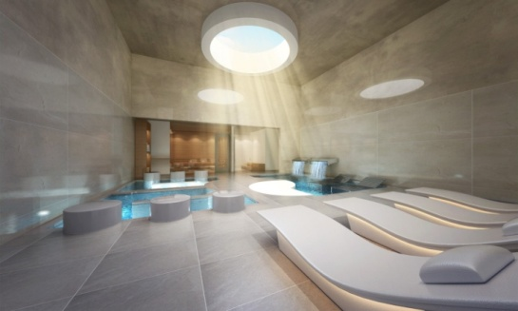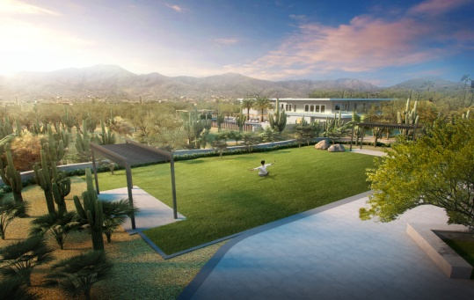
CIVANA Carefree
New GreenTree Inn Opened in Pinetop
GreenTree Hospitality Group, Inc. is pleased to announce the opening of its ninth GreenTree Inn U.S. location, and seventh branded property in Arizona. The newest GreenTree Inn & Suites hotel opened its doors in early April 2018 in Pinetop, Arizona (formerly Holiday Inn Express Pinetop). The 73-room property includes free high-speed Wi-Fi, a daily hot breakfast buffet, welcoming lobby with business center as well as an indoor pool, spa and sauna and a well-equipped fitness center. Large family and business-friendly rooms focus on sustainable practices, including eco-friendly Keurig coffee pods, soap dispensers and LED lighting. The GreenTree Pinetop property in Northern Arizona allows guests the ability to check out and explore the mountains and serene vistas, including 680 miles of streams that feed 34 lakes of the Apache and Sitgreaves National Forests. Hotel guests can sightsee from the Mogollon Rim, fish in scenic waters or watch the sunrise atop Mount Baldy. In the summer, mountain biking and horseback riding are great ways to see the mountains, while in the winter guests can choose from the 65 ski runs at Sunrise Park Resort.

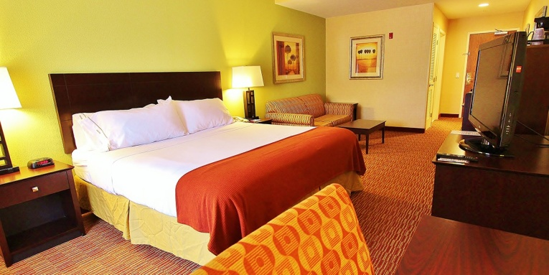
GreenTree Inn & Suites

W Scottsdale Launches “Be-Spoke” Bike Program
Be-Spoke is a new cycling program available exclusively at W Scottsdale. Inspired by the hotel’s fitness-minded clientele, Be-Spoke includes a fleet of bikes available free to guests along with customizable solo itineraries and engaging group rides, allowing riders to fully experience the desert destination at their own speed. The Be-Spoke Cycling Program is part of the W Scottsdale FUEL initiative, which gives guests the tools to relax and make the most of their time in Scottsdale. With the fleet of new bikes, guests can pedal through tours of Downtown Scottsdale led by knowledgeable hotel staff, or tap into a range of custom self-led itineraries catering to individual goals and preferences. To ensure guests are fully fueled for their rides around town, the hotel will equip riders with water and snacks before they head out. Availability is first come, first served, and all riders must be 18 years or older (or accompanied by an adult).
Be-Spoke cycling program at W Scottsdale

Castle Hot Springs Resort Returning In October
Located just northwest of the Phoenix Metropolitan Area, Castle Hot Springs was Arizona’s first luxury resort. For centuries, the Castle Hot Springs area was a medicinal healing habitat for the Yavapai and Apache Indians. In 1896, Castle Hot Springs opened as a resort getaway for wealthy tourists seeking solitude and the spring’s recuperative powers. In 1976, a fire at the main lodge closed the resort. After the fire, the resort was donated to ASU and was used for university retreats and outings before being sold in the 1980’s. A local partnership, with multi-generational roots in Arizona, purchased the property in 2014 and began restoring remnants of the original resort. Castle Hot Springs will consist of 32 luxury accommodations, including Spring Cottages which will have piping directly from the hot springs. The resort will also include an organic farm that will produce more than 150 varieties of rare fruits and vegetables for the restaurant and bar. Castle Hot Springs will cater to guests seeking seclusion, adventure, and relaxation, but will also be an ideal venue for weddings, corporate retreats, and family reunions. The hot springs is fed from a 10,000 foot underground cistern that produces more than 300,000 gallons of pure 120-degree mineral water per day. Castle Hot Springs is scheduled to reopen this fall.

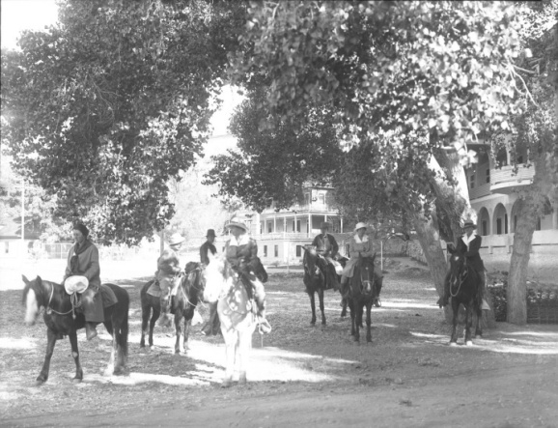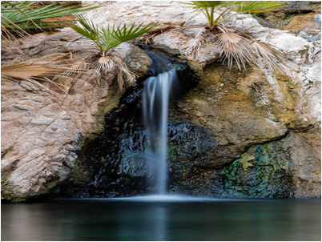
Castle Hot Springs Resort

The Westin Tempe breaks ground in the heart of Downtown Tempe
The Westin Tempe has officially broken ground in the heart of Downtown Tempe on Seventh Street between Mill and Myrtle avenues. Developed by Las Vegas-based CAI Investments, the 18-story Westin Tempe will be a full-service business hotel. Westin Tempe is planned to feature state-of-the-art guest rooms and corridors, with custom-designed elements and artwork, as well as energy conservation practices. The hotel will also feature a rooftop pool lounge, the brand’s signature WestinWORKOUT fitness studio, full-service restaurant, coffee shop and 14,000 square feet of meeting space. Westin Tempe is scheduled to open in third quarter of 2019. Westin Tempe
Rebranded Hotel McCoy Opening After $2.5 Million Facelift
Featuring an A-shaped entrance, the mid-century-modern Hotel McCoy will open in summer 2018 after completing a major renovation and rebranding. The single-story boutique property will offer 93 rooms averaging 280 square feet with private bathrooms, free Wi-Fi, and an outdoor pool and cedar-lined sauna. Everything will be locally sourced and eco-friendly, from lobby art to furniture and food and beverages. The hotel is located less than five miles from downtown Tucson and the University of Arizona in rising and colorful Barrio Ochoa.

Attractions

Medieval Times Breaks Ground on Tenth Castle, First in Arizona
Medieval Times Dinner & Tournament broke ground on its tenth North American castle, to be located in the Salt River Pima-Maricopa Indian Community’s Talking Stick Entertainment District in Scottsdale, Arizona. With construction slated for completion in early 2019, the 79,000 square-foot 11th Century-style castle will be the only entertainment venue of its type in Arizona. Knights engage in displays of strength and skill, as fans cheer their champions over a four-course, utensil-free feast, much as they might have 10 centuries ago. Located on a 10 acre lot, adjacent to the Salt River Fields, Medieval Times’ Scottsdale castle will be one of the most architecturally distinctive among its nationwide properties. Designed in muted earth tones to appear as if it is organically rising from the land, the colossal, stone-walled edifice will incorporate the iconic motifs of Medieval Spain. Medieval Times Dinner & Tournament was founded in 1977 in Spain, based on authentic medieval history and the true story of a noble family with documentation dating back to the 11th Century.

Medieval Times Dinner & Tournament

Culture/Heritage

New Exhibition at the Museum of Northern Arizona
The Museum of Northern Arizona (MNA) unveiled an expanded and revitalized permanent exhibition on the Native Peoples of the Colorado Plateau, giving deeper insights to the 10 tribes that have called the region home for centuries. It is the first major renovation of the museum’s Native American exhibition in nearly forty years. In an approach that is being viewed as trailblazing, curators of the exhibition partnered with 42 members of the Colorado Plateau tribes to select the 342 items being displayed. The tribal consultants also determined the exhibition’s themes and developed the educational content that will put the objects and photographs into historical and cultural context. The collaboration between MNA curators and the tribal representatives ensures that the gallery not only illuminates but respects the people and cultures it explores and the spiritual importance of the traditions they are sharing. The materials in the exhibition are from the Zuni, Acoma, Southern Ute, Southern Paiute, Hopi, Havasupai, Hualapai, Yavapai, Dilzhe’e Apache, and Diné (Navajo) communities. Items in the displays will run the gamut from weavings, pottery and fine silverwork to toys, tools and even a skateboard.

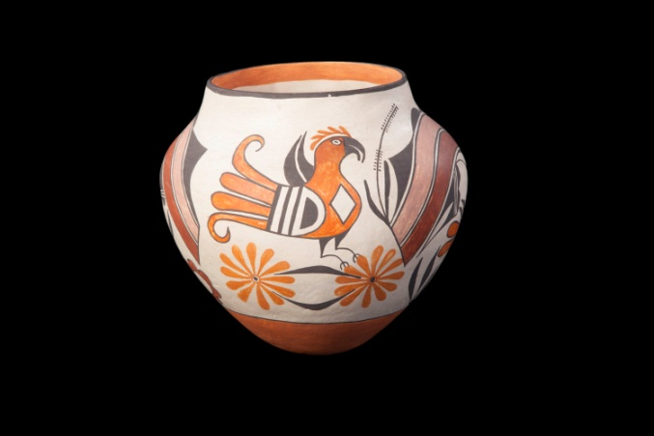
Acoma Pot / Walpi Woman by Hopi artist Mavasta Honyouti

Connect:
@arizonatravel
@visit_arizona
www.youtube.com/user/ArizonaTourism
Newsroom: http://newsroom.visitarizona.com/
Official State Visitors Guide: http://www.visitarizona.com/visitors-guide
Additional inspiration: http://www.visitarizona.com/planning/local-word

