A Brief Update of News Around Arizona
September 2017
The Arizona Office of Tourism is pleased to provide this monthly update of new and noteworthy items within Arizona’s tourism industry. For more information, contact Becky Blaine at bblaine@tourism.az.gov, Kim Todd at ktodd@tourism.az.gov or Marjorie Magnusson at mmagnusson@tourism.az.gov.

Hotel News
Hotel Valley Ho completes mid-century redesign
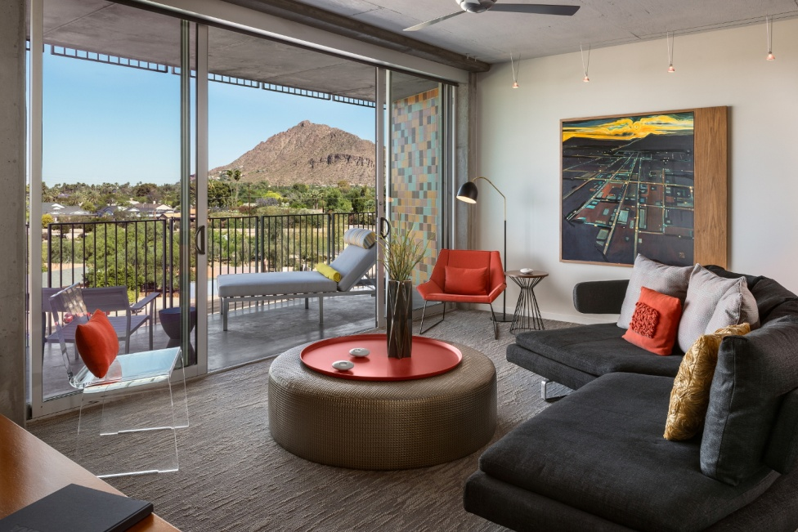
Hotel Valley Ho, Downtown Scottsdale’s mid-century modern icon since 1956, has revamped its rooms and suites in The Tower. The design overhaul of this luxurious hotel within a hotel was completed in September, featuring new, mid-century-inspired elements including lighting, décor, flooring, and millwork. Existing signature pieces including B&B Italia sofas and Knoll Lounge Chairs were reupholstered in fabrics with bold jewel tones. The new look follows the hotel’s signature style, which blends contemporary modern with mid-century influences. Each room and suite in The Tower features floor-to-ceiling glass and views of Downtown Scottsdale or Camelback Mountain. Tower Suites are complete with full kitchens, walk-in closets and washer/dryers for the ideal home away from home.

Photo courtesy of the Hotel Valley Ho.

JW Marriott Desert Ridge Resort & Spa adds six luxury, poolside cabana cottages
The JW Marriott Desert Ridge Resort & Spa has completed phase II of the resort’s summer poolside enhancement program with the addition of six new, luxury cabanas. The 120 square foot private, covered cabanas feature cushioned chaise lounge chairs and sectional sofa seating, a cooling misting fan, refrigerator with complimentary bottled water, towel service, a digital safe for personal belongings, private television with DIRECTV and complimentary WiFi so guests can stay connected. Each cabana has its own private attendant for ordering any food and beverage. Phase I of the 950-room resort’s $3.6 million renovation of its “Just A Splash” poolside retreat included the addition of a U-shaped bar and dining area; three new fire pits, two of which are sunken and surrounded by water and recessed lighting; a new Grab & Go bar; eight TV's that are 50" or larger; a new state-of-the-art sound system woven into the landscaping; wireless capabilities; intimate enclaves, landscape lighting and misting systems, and a raised upper dining area that includes recreational activities including ping pong and shuffleboard.

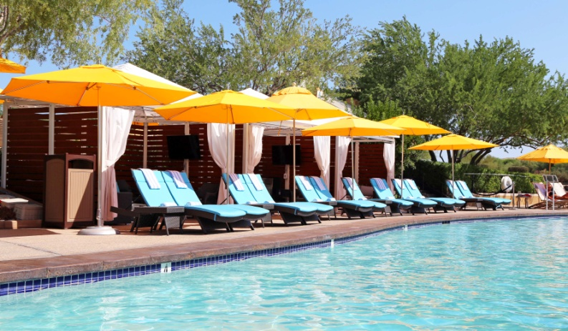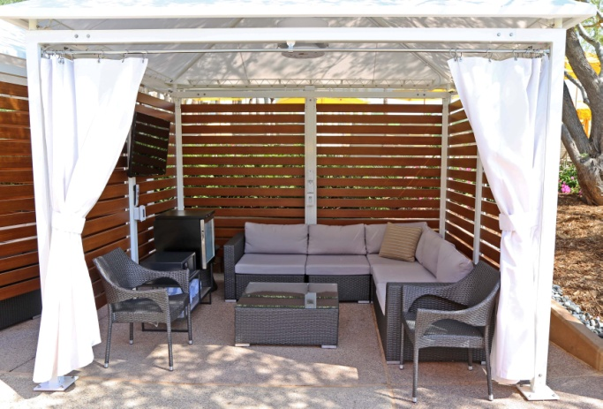
New cabanas at the JW Marriott Desert Ridge Resort & Spa
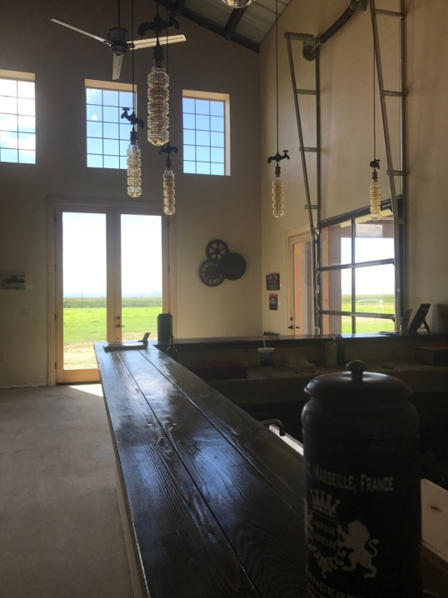
Culinary
Kief-Joshua Vineyards just opened a tasting room in Willcox
Kief-Joshua Vineyards is a small family wine making business with 20 acres of vineyards in Elgin, and 40 acres in Willcox. A tasting room in Elgin has been operating for several years. As the Willcox area was recently granted AVA (American Viticultural Area) status, meaning this area is now recognized as a unique and distinctive wine-growing region in the United States the owners decided to open an additional tasting room in Willcox. The tasting room in Willcox is located at 4923 E. Arzberger Road in Willcox and opened this month. The tasting room is open Fridays through Sundays, from 11 a.m. to 5 p.m. For only $10 customers get a souvenir glass and 5 (1oz) pours, or $7 if you bring your own wine glass.

Kief-Joshua Vineyards in Willcox
General
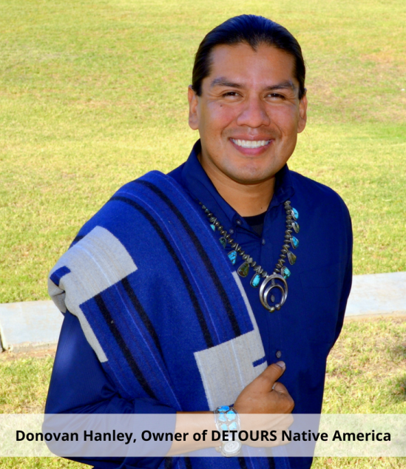
Welcome to DETOURS Native America
﻿DETOURS of the Southwest has added a new product – DETOURS Native America. Created by owners Donovan Hanley and Jeff Slade, DETOURS Native America strives to enhance the universal community through voluntourism, immersive experiences, and historical storytelling from a native perspective. For the first time, non-natives will be able to experience Native American heritage, culture, cuisine and celebration on a local level. Multi-day tours begin in 2018.
Accolades

Prescott named best destination for nature lovers in Arizona by Expedia
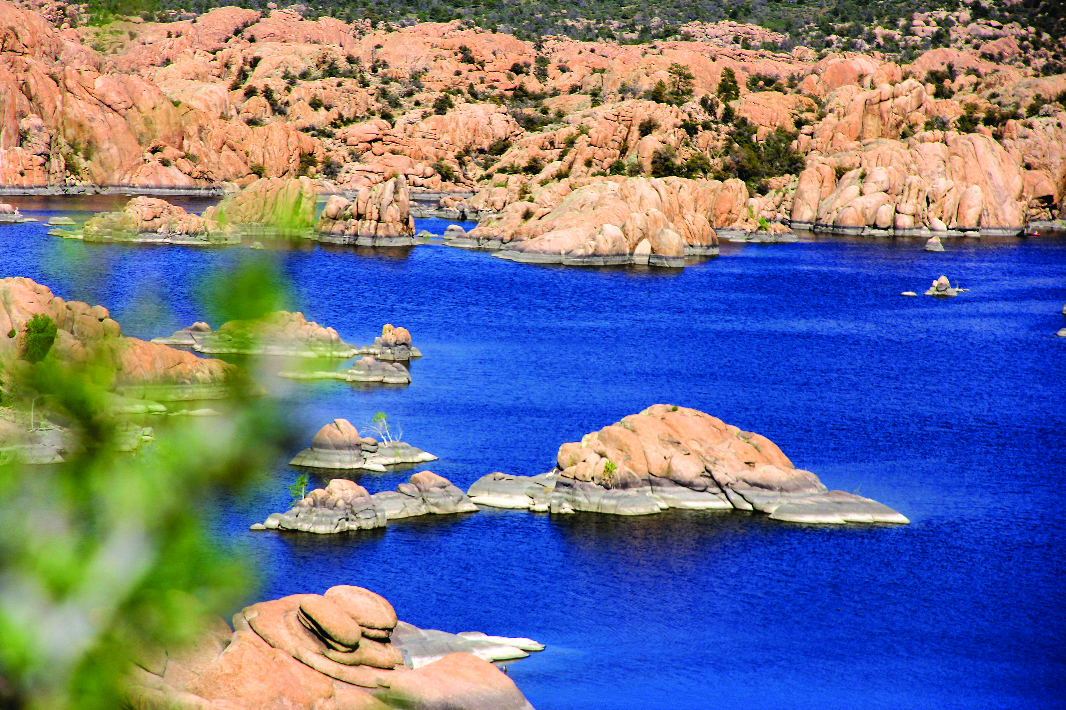
Prescott has been named the Best Destination in the State of Arizona for Nature Lovers by travel website Expedia.com’s Viewfinder travel blog. The article cited the 1.25 million acres of National Forest, 16 parks, three lakes, and miles of trails. City Manager Michael Lamar, agrees with the Expedia ranking and adds, “We are fortunate to boast the Prescott National Forest; the one-of-a-kind Granite Dells; Willow, Watson and Goldwater lakes; and 450 miles of multi-use trails.”

Granite Dells in Prescott
Kartchner Caverns State Park receives International Dark-Sky Association designation
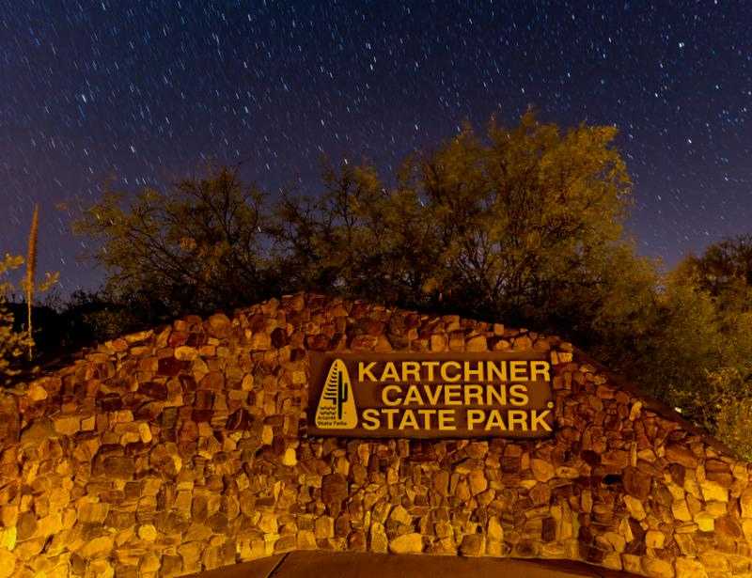
Kartchner Caverns State Park has the distinction of becoming an International Dark Sky Park, designated by the International Dark-Sky Association (IDA). It is the second state park in the Arizona State Parks system to receive IDA recognition and the fifth overall in the Grand Canyon State. Oracle State Park received the designation in 2014. The Flagstaff area National Monuments and the Grand Canyon National Park are also recognized Dark Sky Parks. Dark Sky communities in Arizona include Flagstaff, Sedona, and Big Park/Village of Sedona. The Dark Sky Places Program was started by IDA in 2001 to encourage communities around the world to preserve and protect dark sites through responsible lighting polices and public education. The night sky near Benson
Connect:
@arizonatravel
@visit_arizona
www.youtube.com/user/ArizonaTourism
Newsroom: http://newsroom.visitarizona.com/
Official State Visitors Guide: http://www.visitarizona.com/visitors-guide
Additional inspiration: http://www.visitarizona.com/planning/local-word

