A Brief Update of News Around Arizona
July 2017
The Arizona Office of Tourism is pleased to provide this monthly update of new and noteworthy items within Arizona’s tourism industry. For more information, contact Becky Blaine at bblaine@tourism.az.gov, Kim Todd at ktodd@tourism.az.gov or Marjorie Magnusson at mmagnusson@tourism.az.gov.

Adventure

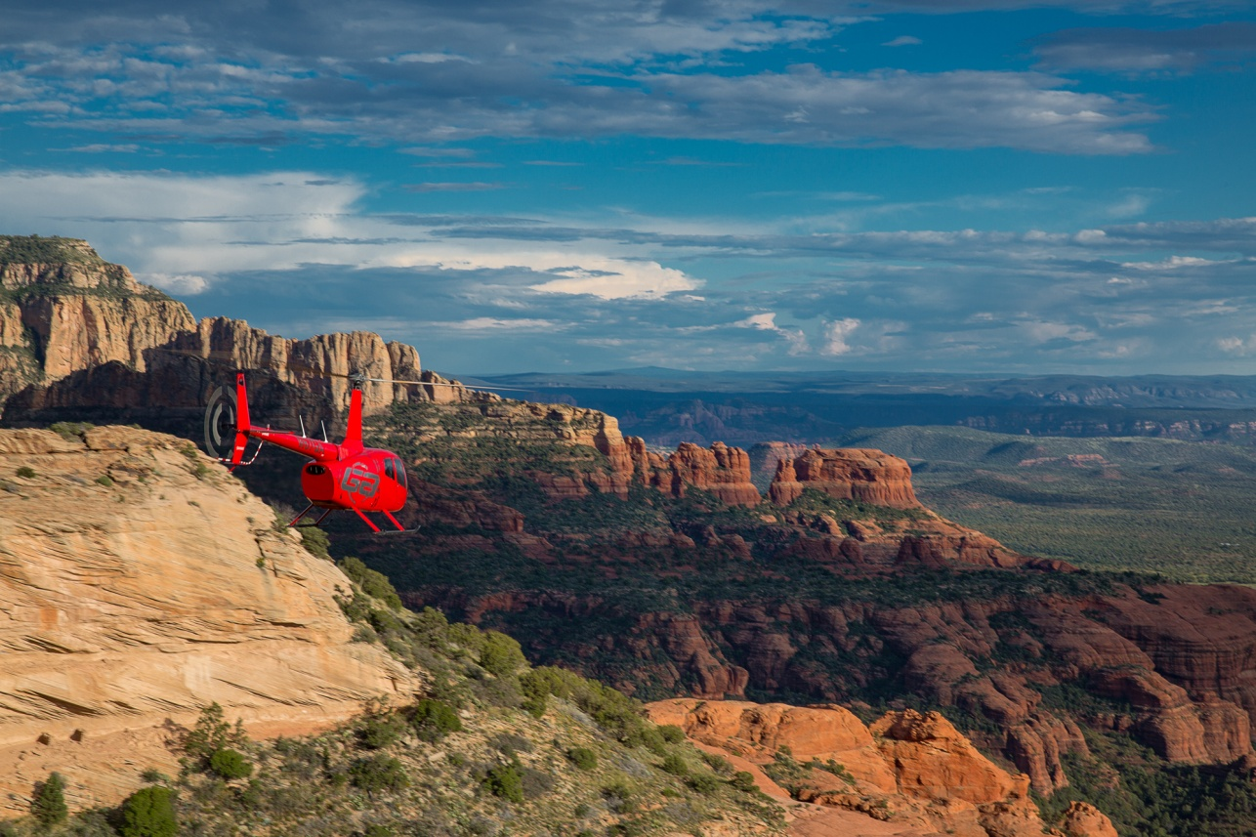
Guidance Air, a new Sedona-based helicopter tour company
Guidance Air began offering helicopter tours of Sedona in November 2016. Offering five different tours of the red rocks of Sedona, tours range from fifteen minutes to one-hour. The flights depart from the Sedona Airport and include views of the rugged landscape of spires, mesas and deep secluded canyons which surround the city. Seating up to four passengers, each is a window seat in the Robinson® helicopters. The aircraft are fully air-conditioned and equipped with Bose® noise-cancelling headsets. Flights may also be chartered to tour other northern Arizona sites. Guidance Air soaring over Sedona
Flagstaff’s 3rd New Lift in Three Years!
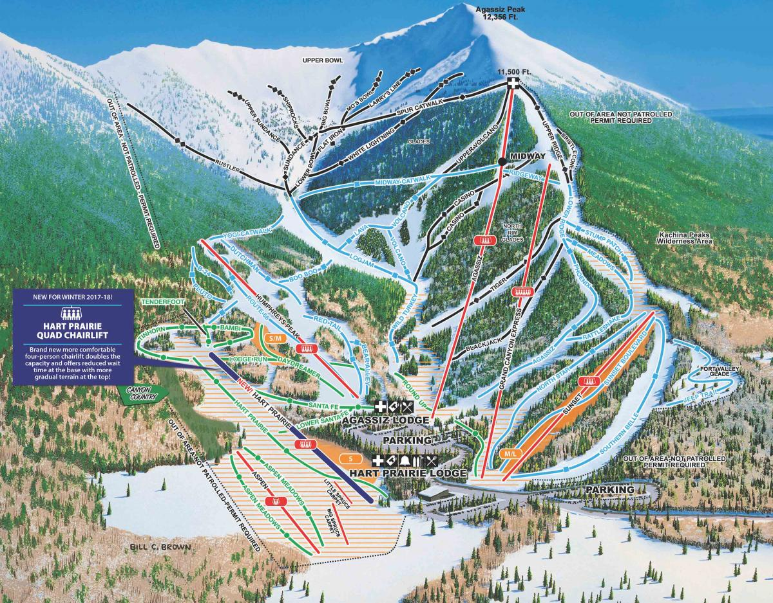
Hart Prairie chairlift is the primary and longest beginner lift at Snowbowl just north of Flagstaff. The existing lift, built in 1981, was a two passenger seat lift. The new Hart Prairie lift is a four-seater with restraining bars, foot rests, and thick padded seats. The four-passenger lift allows families to ride together and enables ski instructors to ride with more guests, especially children. The length of the lift is 2,533 feet with a vertical of 518 feet.
The new Hart Prairie lift has an uphill capacity of 1800 pph (people per hour), which is double the capacity of the older double chairlift it is replacing. This lift will feature Arizona's first loading conveyor, which is similar to a moving sidewalk and designed to make loading the lift easier and more efficient. Loading conveyors work very well for beginners and provide a Snowbowl's two stand alone conveyors.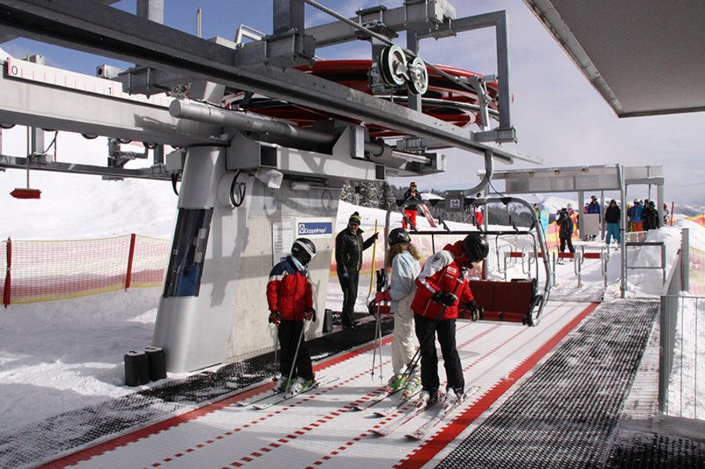
Flagstaff’s new Hart Prairie lift will feature Arizona's first loading conveyor
Arizona Snowbowl has the best learn to ski and snowboard progression terrain in the entire western US with Hart Prairie boasting a wide open and gentle meadow, allowing beginners to learn and gain confidence on the slopes. The Hart Prairie area of the resort has two chairlifts and two surface conveyors just for beginners, which offers terrain-based learning.
Arizona Snowbowl's trail map with the new Hart Prairie Chairlift

Culinary
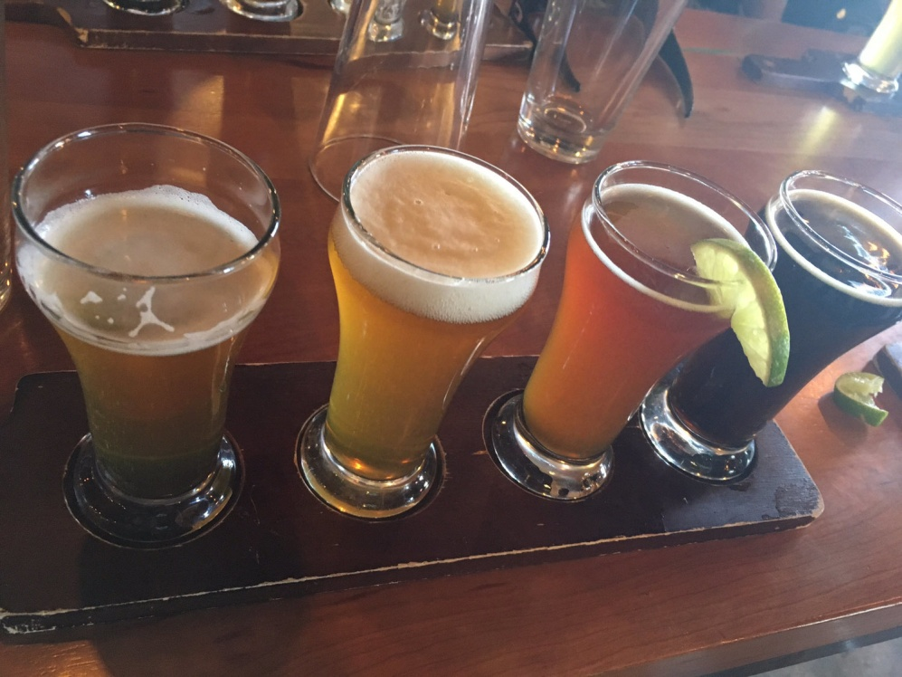
Guided tours of Tucson craft brews begin
Old Pueblo Brew Tours recently opened in Tucson and offers a mobile artisan craft beer journey through some of the Old Pueblo's best breweries. The new tours currently are scheduled on Saturdays for 4-5 hours with 3-4 stops. Guests meet at a designated brewery and are shuttled by van during the tour. Brewery participants include the established Borderlands Brewing Co. and newbie Dillinger Brewing Co. The company's name is taken from Tucson's nickname: "pueblo" is Spanish for "town" or "village".

A journey through some of Tucson’s best breweries

OdySea in the Desert now features “Polar Play”
While temperatures outside OdySea in the Desert, in Scottsdale, can exceed 100 degrees in the summer, it is always an icy 23 degrees inside the new Polar Play attraction, featuring an indoor ice bar, along with a playground for children. Everything inside Polar Play is made of ice — the bar, the drink glasses, walls and chairs. Phoenix ice sculptor Mark Armitage has created ice sculptures for the 3,500-square-foot space, which include penguins and polar bears. Other icy activities include a game table made of ice, benches, and an ice tunnel for children.
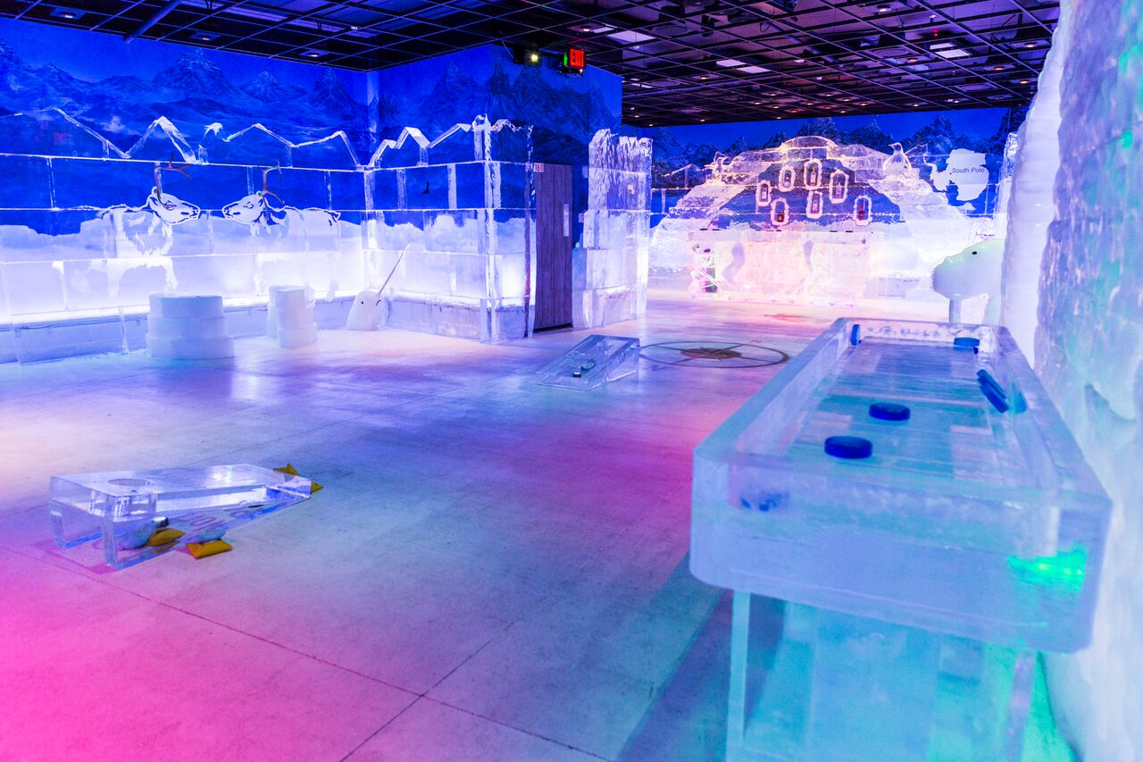
Staying cool at OdySea in the Desert

Hotel News
Additional renovations for the Royal Palms Resort and Spa
The Royal Palms Resort and Spa, in Phoenix, is undergoing a multimillion-dollar renovation to every one of its 119 guestrooms, including its plush Presidential Suite, and select meeting and event spaces. This wave of upgrades comes on the tail of recent enhancements to the resort’s pool and lounge area, event lawns and lush landscaping. Rooms will be lightened and brightened with earthy desert hues and eclectic furnishings, plus new artwork and finishings to reflect lavish Mediterranean textures. The pool deck now features cabanas with orbit beds and a new seasonal culinary and cocktails menu designed by Executive Chef Todd Allison. Guestroom and event space upgrades will be completed in phases. Many guest rooms are completed and total renovations are expected to finish in fall 2017.
New luxury resort opens in Scottsdale
Hyatt Hotels Corporation’s Andaz Scottsdale Resort & Spa, opened in December 2016. As with other Andaz properties, this Scottsdale resort immerses guests with experiences indigenous to the location. The resort partners with nearby artist compound Cattle Track, the longtime home and studio of some of the Southwest’s most notable artists, such as Philip Curtis and Fritz Scholder. Much of the artwork and dishware on the property is created by Cattle Track artists. The property’s interior features mid-century desert designs that pay homage to the 1950s. Andaz Scottsdale Resort & Spa features 201 bungalow-style guest rooms, the full-service Palo Verde Spa & Apothecary – known for its treatments using ingredients from a local Sedona botanist – and 46,000-plus square feet of meeting and event space on more than 22 acres of land. Guests can sample an assortment of small plates and shareable dishes at the resort’s signature restaurant Weft & Warp Art Bar + Kitchen.
Chef Adam Sheff, draws inspiration from local flavors and ingredients to create an innovative dining experience in a setting overlooking Camelback Mountain.
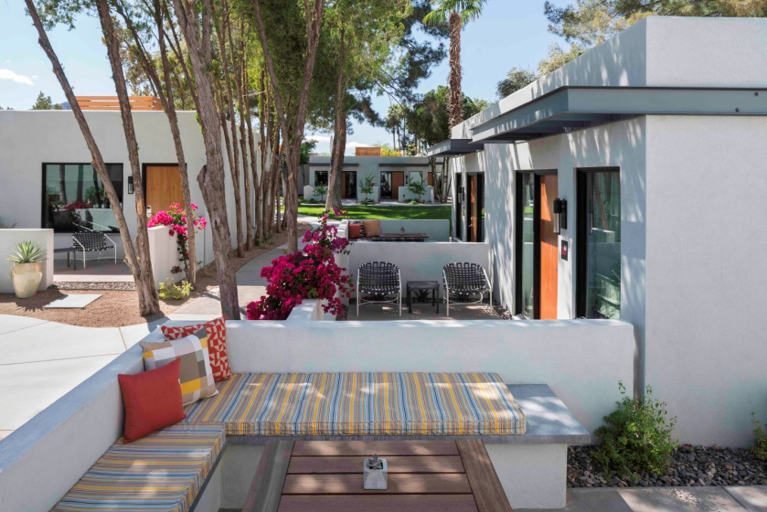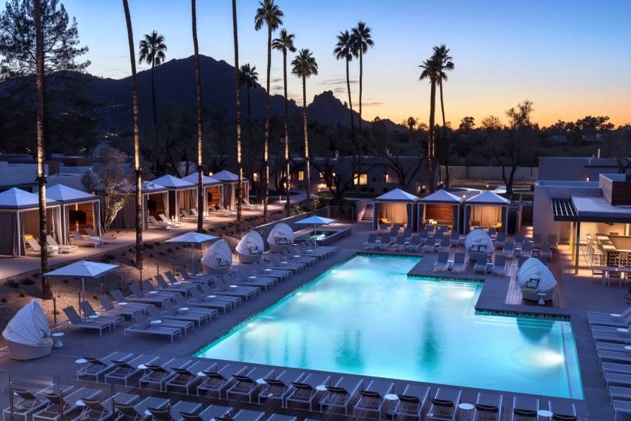
A perfect sunrise and sunset at the new Andaz Scottsdale Resort & Spa

General

Phoenix Sky Harbor to begin nonstop flights to Frankfurt, Germany on Condor Airlines
Phoenix Sky Harbor will soon offer nonstop flights between Phoenix and Frankfurt, Germany. Condor Airlines, part of the Thomas Cook Group, will fly on Mondays and Fridays from May 2018 through September. Condor will operate a Boeing 767-300ER with 259 seats in business, premium and economy classes. All Condor passengers receive complimentary checked baggage, beverages, meals and in-flight entertainment. Condor’s Business Class features lie-flat seats, a personal in-seat, premium touch-screen entertainment system, power and USB ports at every seat and gourmet, five-course meals with complimentary wine, beer and cocktails. Business Class passengers also have access to priority check-in and business class lounges at most airports. Premium Class features seats with added legroom, leg rests and adjustable headrests, a premium in-flight, in-seat entertainment system with an extended program, USB ports at every seat, premium meals and complimentary beverages. Beginning May 18, 2018, Condor will leave Phoenix Mondays around 11:00 p.m., arriving in Germany at 7:00 p.m. the next day. The flight will leave Germany around 5:30 p.m., arriving Phoenix at 9:00 p.m. On Fridays Condor will leave Phoenix around 5:00 p.m. arriving in Germany at 1:00 p.m. the next day. In Germany it will leave at around 11:30 a.m. on Fridays, arriving Phoenix at 3:00 p.m.
Alaska Airlines launches nonstop service between San Jose and Tucson
Alaska Airlines will launch daily nonstop service between Tucson (TUS) and Mineta San Jose International Airport (SJC) on August 28, 2017 providing quicker access between Tucson and the tech company campuses of Silicon Valley and south Bay Area. The flight will leave San Jose at 5:35 p.m. each evening, arriving in Tucson at 7:45 p.m. The return flight will depart Tucson at 7 a.m., arriving in San Jose at 9:24 a.m. Nonstop service will be aboard an Embraer 175 jet featuring 12 seats in first class and 64 coach seats.
Sun Country launches nonstop service between Minneapolis-St. Paul and Tucson
Sun Country Airlines will return to Tucson International Airport when they launch seasonal nonstop service between Tucson (TUS) and Minneapolis-St. Paul (MSP) on December 21, 2017. The flight will operate three days a week; Tuesdays, Thursdays and Sundays through April 15th. The flight will depart Minneapolis-St. Paul at 7:55 am and arrive in Tucson at 10:20 am. The return flight will depart Tucson at 11:10 am, arriving in Minneapolis at 3:10 pm. Nonstop service will be aboard a Boeing 737-700 featuring 12 first-class recliner seats and 114 coach seats.
Allegiant announces eight new nonstop destinations at Phoenix-Mesa Gateway Airport
Allegiant Air is adding eight new nonstop destinations at Phoenix-Mesa Gateway Airport. The new routes include major Midwest destinations Indianapolis, Milwaukee, Kansas City, Louisville, Omaha and St. Louis/Belleville. Additionally, Boise will join the list of Mountain West destinations served by Gateway Airport. And, for the first time, nonstop service to Florida launches with flights to Tampa/St. Pete Florida.
Air Canada announced nonstop service between Phoenix and Montreal
In February 2018, Air Canada will begin nonstop service between Phoenix Sky Harbor International Airport and Montreal. The flight, served by an Airbus A319, will operate three times weekly in the winter and spring, from February 22 – May 28. The new route will offer the only non-stop service between Phoenix and Montreal.
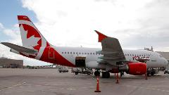
Accolades

Cowboy Ciao named as one of America’s best wine restaurants
Cowboy Ciao of Scottsdale has been included on Wine Enthusiast Magazine’s 2017 list of “America’s 100 Best Wine Restaurants.” Every year the magazine’s editors search the country for the most dynamic, charming and innovative wine and food experiences. This curated list spotlights the restaurants that showcase great beverage programs along with notable food, atmosphere and excellent service.
Sierra Vista designated a bicycle friendly community
The League of American Bicyclists has announced that Sierra Vista earned a bronze level designation as a Bicycle Friendly Community. The designation reflects the ways Sierra Vista supports bicyclists including efforts to share bicycle safety education opportunities and access to bicycle amenities like Sierra Vista’s 30-mile network of multi-use paths. Sierra Vista is now one of 416 communities in the nation — and 11 in the state of Arizona — that have received a Bicycle Friendly Community award. The City also provides free pocket maps to help riders find safe, bicycle-friendly routes through the community and to explore local mountain-biking trails. These maps are available at the Visitor Center in the Oscar Yrun Community Center, located at 3020 E. Tacoma Street, local bike shops, or online at www.sierravistaaz.gov/download-maps.
Sierra Vista joins other Arizona cities recognized with a bronze award including: Chandler, Cottonwood, Gilbert and Phoenix. Arizona Silver award cities include: Flagstaff, Mesa and Sedona. And, Arizona Gold award cities include: Scottsdale, Tempe and Tucson-East Pima County Region.

One of the 10 best whiskeys in the entire country
Esquire Magazine just named Tucson’s Whiskey Del Bac Dorado The 7th Best Craft Whiskey in the U.S. Forbes Magazine also included Whiskey Del Bac Dorado in The Ten Best American Craft Whiskeys for Fathers’ Day. And, they took two Double Gold Medals in as many years at the San Francisco World Spirits Competition, the biggest spirits competition in the country.
"Best Arizona Attraction" by USA Today Readers' Choice

Kartchner Caverns State Park has been named the "Best Arizona Attraction" by USA Today. Last year, Kartchner also won the "Best Cave in the USA" award from the same Readers' Choice group. For the full list of top 10 Arizona Attractions, visit the 10Best page.

Connect:
@arizonatravel
@visit_arizona
www.youtube.com/user/ArizonaTourism
Newsroom: http://newsroom.visitarizona.com/
Official State Visitors Guide: http://www.visitarizona.com/visitors-guide
Additional inspiration: http://www.visitarizona.com/planning/local-word

