January 2017
The Arizona Office of Tourism is pleased to provide this monthly update of new and noteworthy items within Arizona’s tourism industry. For more information, contact Tony Alba at talba@tourism.az.gov, Marjorie Magnusson at mmagnusson@tourism.az.gov or Kim Todd at ktodd@tourism.az.gov.

Adventure

Under Canvas, a luxury camping and outdoor events company, will open Under Canvas Grand Canyon in June. It will be the first eco-friendly, safari-inspired glamping resort of its kind in Arizona. It is located on 56 acres in Williams near historic Route 66 at the base of Bill Williams Mountain, 40 minutes from the Grand Canyon. Permanent wood and canvas tents are available in three categories with amenities such as wood burning stoves, luxurious linens and Adirondack chairs. Deluxe safari tents include en-suite bathrooms with eco-friendly toiletries, a hot shower, sink and flushing toilet or an added cast iron roll top bathtub. Additional activities and adventures are available, such as whitewater rafting, horseback riding, scenic flights, zip lining, safari Jeep tours and trips on the Grand Canyon Railway. Under Canvas Grand Canyon is located at 710 E. Route 66, Williams, AZ 86046.

Verde Canyon Railroad is carefully counting each visitor as it prepares to welcome its 2 millionth passenger onto the train this spring. The exact date cannot be predicted, but VCRR estimates it will happen sometime in May. Those hoping to be passenger number 2,000,000 can book passage online.

Hotel Development
The long-anticipated opening of the Mountain Shadows resort in Paradise Valley will take place on Valentine’s Day, February 14, 2017. The new boutique resort will feature a desert modern design, 183 guest rooms, a luxury wing with 42 resort condominiums and suites, a restaurant with an exhibition kitchen, two pools, a high-tech fitness facility, and an 18-hole golf course. The property is on the same site as the historic Marriott Mountain Shadows Resort, which opened in 1959 and closed in 2004.

The Short Course at Mountain Shadows also will open on February 14. The course will feature 18 distinctive par-3 holes, with a bonus “wager” hole. It offers a variety of play options for families, corporate outings, novice players and serious golfers. Golf course architect Forrest Richardson created rugged slopes, rising ridges and dramatic mounds set in the scenic desert landscape and has already been honored by the fifth annual American Society of Golf Course Architects Design Excellence Recognition Program. The Short Course at Mountain Shadows is among only a handful of 18-hole, high-end, par-3 golf courses in the world that are open to the public. Holes play from 60 to 200 yards and golfers will be able to complete 18 holes in just a few hours. With a nod to conservation, the turf area has been reduced by more than 50 percent and the resulting water conservation creates a more environmentally sustainable golf course.

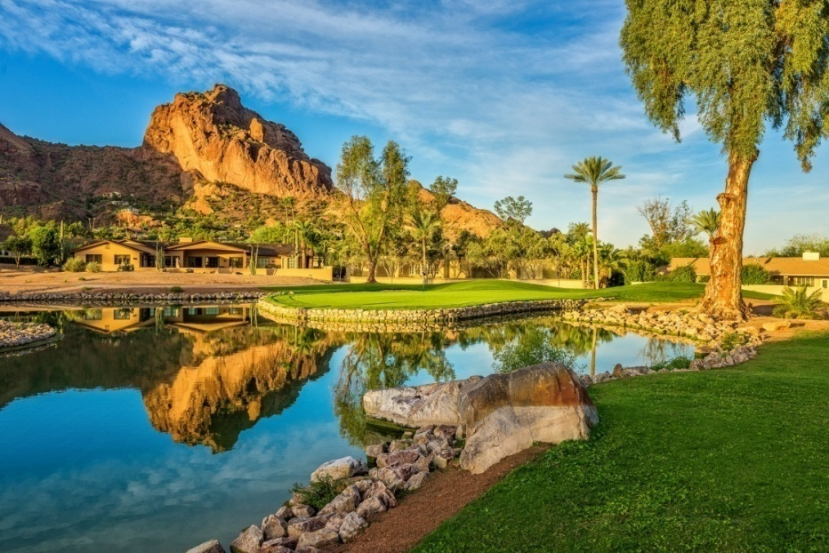
The Short Course at Mountain Shadows

General

After 25 years of requests, Verde Canyon Railroad is introducing a locomotive “ride-along” program for those wishing to see the Verde Canyon from inside the cab of a powerful railroad engine. Not more than 20 people, mostly employees, have experienced the power of 1500 horses under the hood since the railroad’s inception more than two decades ago. Now the kid inside us all may fulfill a childhood fantasy and rub elbows with Verde Canyon Railroad’s engineer and conductor aboard an historic FP7 locomotive. This exclusive experience is available for one person each day, beginning in January 2017.

Verde Canyon RR Engineer

The Powerhouse Museum in Kingman now offers exhibit descriptions in several languages. Translations have been completed in Chinese, Dutch, French and German and some in Italian. The translations are available on-line at http://www.gokingman.com/66museum-text, or using a QR code on site for mobile phone users to follow while visiting the museum. Printouts for visitors who don’t have mobile data service are also available.

Two airlines are increasing their service in Arizona. Air Canada announced its Vancouver-Phoenix route will switch from a seasonal route to a year-round operation on May 1, 2017. In May and June, British Airways will add a second flight three days a week from Phoenix Sky Harbor to London Heathrow Airport. From May 8 to June 2, the flight will operate on Monday, Wednesday and Saturday. Beginning June 6 through July 2, the flight will operate Tuesday, Thursday and Sunday. The added service will help meet demand in the busy summer travel season. British Airways already operates one daily flight serving the Phoenix-London route.

Visitors are invited to attend Beyond the Bricks – Thursday Night Live, a new concert series in Downtown Tempe’s Hayden Square Amphitheater. The event features music from local bands, and food, wine and beer available for purchase. This event is held on Thursday evenings from 5:30-7:30 p.m. through May 2017.

Macerich has announced a multi-phased project to enhance Scottsdale Fashion Square. Plans include a renovation of the luxury wing followed by the addition of residences, class A office space and a new hotel. The first phase of this multi-dimensional project will update and redefine the luxury wing anchored by Neiman Marcus with a striking new entrance and arrival point, two-story storefronts and exterior-facing retail buildings and restaurants. Construction will begin in 2017 with opening planned for fall 2018. Plans also include the addition of new restaurant and food offerings. New services for visitors will include a dedicated luxury valet with a private lounge and house car, platinum-level concierge, personal shopping experts and style consultants, bespoke art installations and fine furnishings, resort-level restrooms, plus a signature fountain and lush gardens influenced by renowned landscapes from around the world.

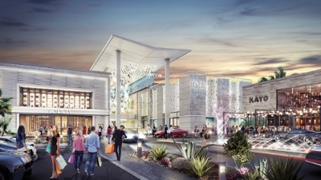
Rendering of upgrades to Scottsdale Fashion Square

Phoenix Sky Harbor International Airport recently unveiled the first phase of a remodeling project to Terminal 3. The renovations are the first stage in the terminal’s three-part, five-year makeover. The first phase includes 31 new common-use ticket counters to allow for flexibility among airlines, a larger consolidated security checkpoint to get travelers to their gates faster and a new museum gallery allowing travelers to enjoy Arizona’s cultural and artistic heritage while waiting for their flights. The entire $590 million modernization project is scheduled to be completed in 2020. Two additional phases will replace the south concourse, upgrade the north concourse and add new food and retail concessions. Currently, Delta, Frontier, Hawaiian and JetBlue airlines operate out of the terminal.

Arizona’s only professional soccer franchise changed its name from Arizona United Soccer Club to Phoenix Rising Football Club and announced plans to build a new complex. In collaboration with the Salt River Pima-Maricopa Indian Community (SRPMIC) and the Solanna Group, the club will develop a 15.8-acre soccer-specific training and 5,000-seat stadium facility bordering the cities of Tempe and Scottsdale. The club plans to kick off the 2017 season at the new Phoenix Rising FC soccer complex. The club is part of the United Soccer League, the largest professional soccer league in the world with 29 teams in 19 U.S. states and three Canadian provinces during the recent 2016 season.

Accolades
Phoenix Sky Harbor International Airport ranks 10th in the world for on-time arrivals and departures according to the annual Punctuality Report produced by AOG Aviation Worldwide Ltd. The report found that nearly 83 percent of flights at Phoenix Sky Harbor were on time, arriving or departing within 15 minutes of schedule. Nationally, Sky Harbor came in at No. 5 for major U.S. airports. (BizJournals.com/Phoenix, Jan. 5)

Paradise Valley was rated the #2 most-comfortable city in America by travelers in a recent article by Expedia. Guest reviews were analyzed to determine the cities across the United States with the highest ratings in hotel comfort. Tourists often consider recommendations from other travelers and the conditions of accommodations when determining new places to visit and this feature signals visitors will be comfortable and welcomed when staying in a city.
Read the article: 101 Most Comfortable Cities

Connect:
Facebook: @arizonatravel
Twitter: @AZTourismPR
Instagram: @visit_arizona/
YouTube: www.youtube.com/user/ArizonaTourism

